Working to rid our Primary Schools of Pit Toilets

By Steuart Pennington

“Within 30kms of my old school in the Midlands of KZN there are 5 Primary Schools still using Pit Toilets. As part of our programme to improve our 16 footprint schools as functional places of learning, hygiene is critical.

Last year I contacted Breadline Africa to visit our schools, they have initiated a campaign of eliminating pit toilets across the country.

In April we started with Crystal Springs Primary School in Lidgetton, home to 401 primary school learners from the surrounding community. The school has no municipal water and uses a borehole which feeds the water tanks. Learners make use of 11 pit toilets, most of which are in terrible condition with doors missing. They have 6 high flush toilets (some of which are leaking) for the 17 staff and 22 Grade R children, connected to a septic tank. The school has insufficient handwashing facilities.
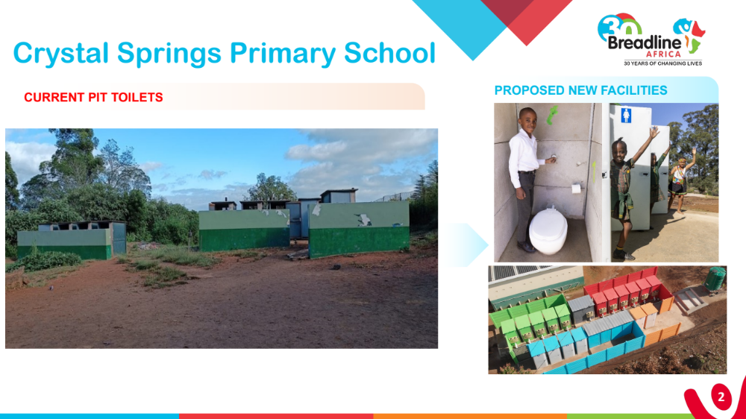

Breadline Africa writes ‘Our aim is to restore dignity to the children by providing 16 hygienic low-flush toilets connected to a new 6,000L septic tank, five waterless urinals and sufficient handwash stations with soap dispensers.

The seats for the younger children will include a smaller integrated seat and concrete. The existing high flush toilets will be replaced with low flush toilets and septic tank will be emptied.’

Breadline Africa has set out to raise R156-million over the next two years to positively impact 120,000 children at 240 schools by replacing unsafe pit toilets at schools with 4,000 modern, eco-friendly sanitation solutions.

Through strategic partnerships and collaboration with all sectors of society, Breadline Africa and its generous donors are working towards creating a brighter future for the children of South Africa, ensuring that every child has access to safe and dignified learning environments. https://breadlineafrica.org/toiletcrisis/.
‘Hopefully, in time, we will rid our five primary schools of Pit toilets as well as attend to on-property dumps and unsatisfactory water fountains in all 16 of our Footprint schools.’

